# Task P5.1.5

ALTER TABLE Student ADD gender ENUM(‘Male’, ‘Female’) ADD Constraint Check_gender CHECK (gender in ( 'Male' OR 'Female');

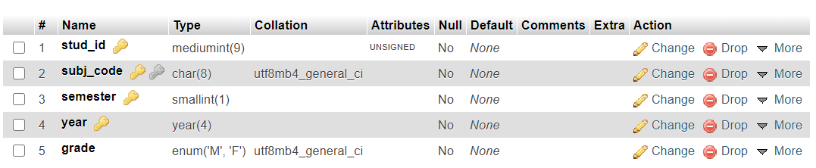

ALTER TABLE subj_Enrolment DROP COLUMN comment;

